**Air quality analysis in tamilnadu**

**Introduction**

In this part we will begin building our project by loading and preprocessing the dataset. Begin the analysis by loading and preprocessing the air quality dataset we Load the dataset using Python and data manipulation libraries (e.g., pandas)

**The coding is as follows:**

To load the air quality dataset in Tamil Nadu using Python and pandas, follow these steps:

1. Install the necessary libraries:

- pandas: pip install pandas

2. Import the required libraries:

Python

Import pandas as pd

3. Load the dataset:

Python

# Assuming the dataset is in a CSV file format

Dataset_path = ‘path/to/air_quality_dataset.csv’

Df = pd.read_csv(dataset_path)

Replace ‘path/to/air_quality_dataset.csv’ with the actual path to your air quality dataset file.

Now you have loaded the dataset into a pandas DataFrame named df. You can proceed with further data manipulation and analysis using pandas and other libraries.

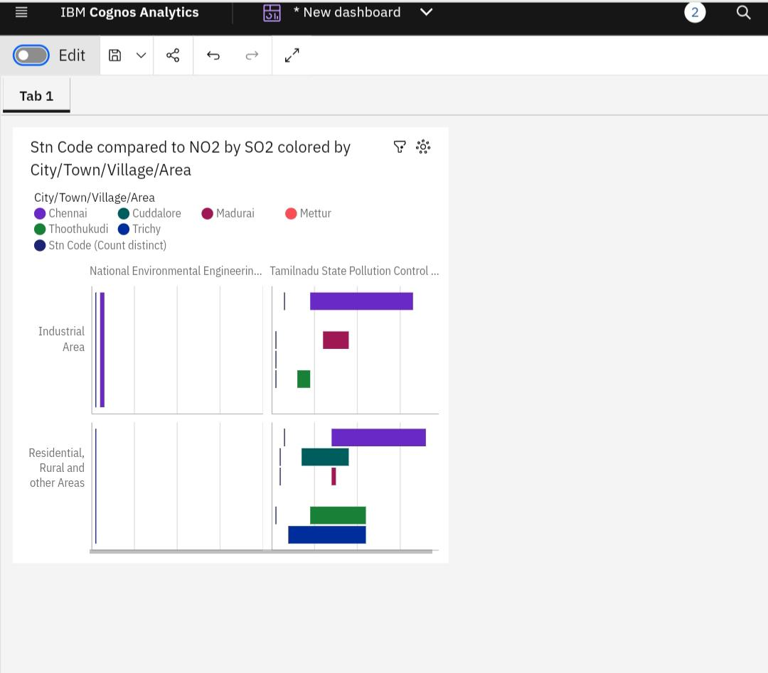The visualization images created according to given dataset through ibm platform is represented as:

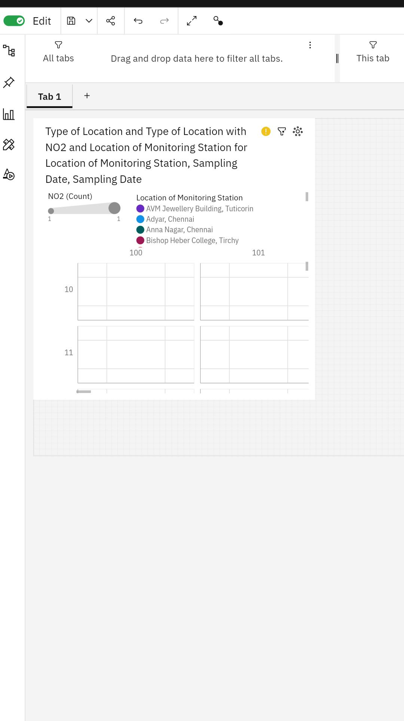

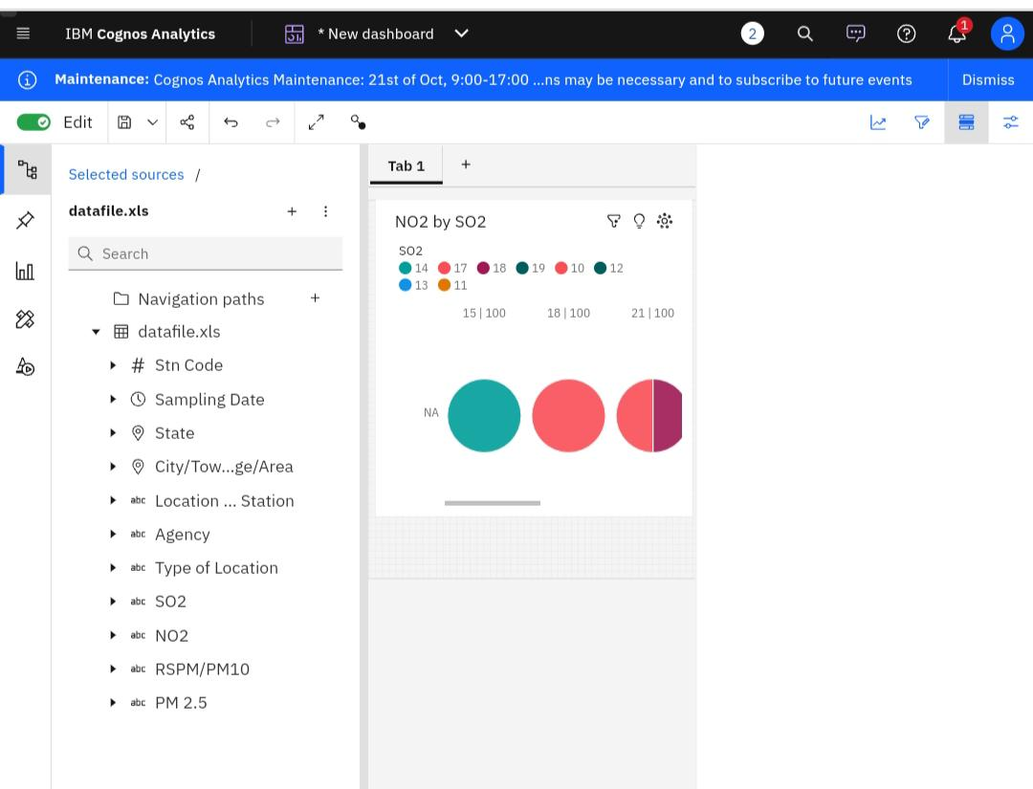

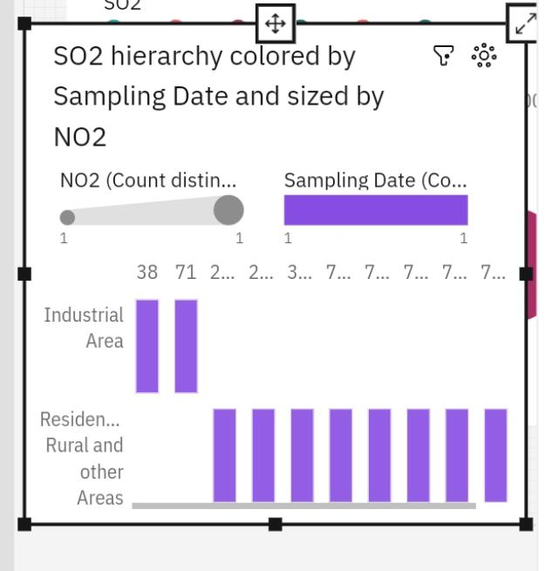

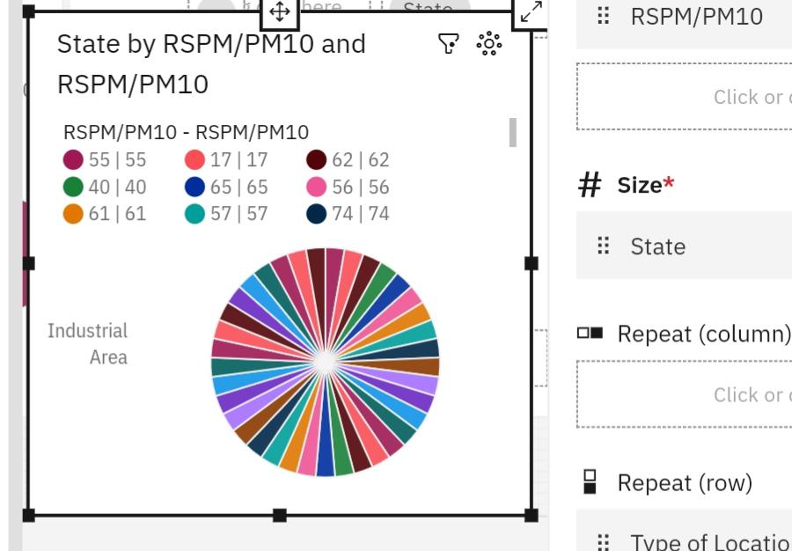

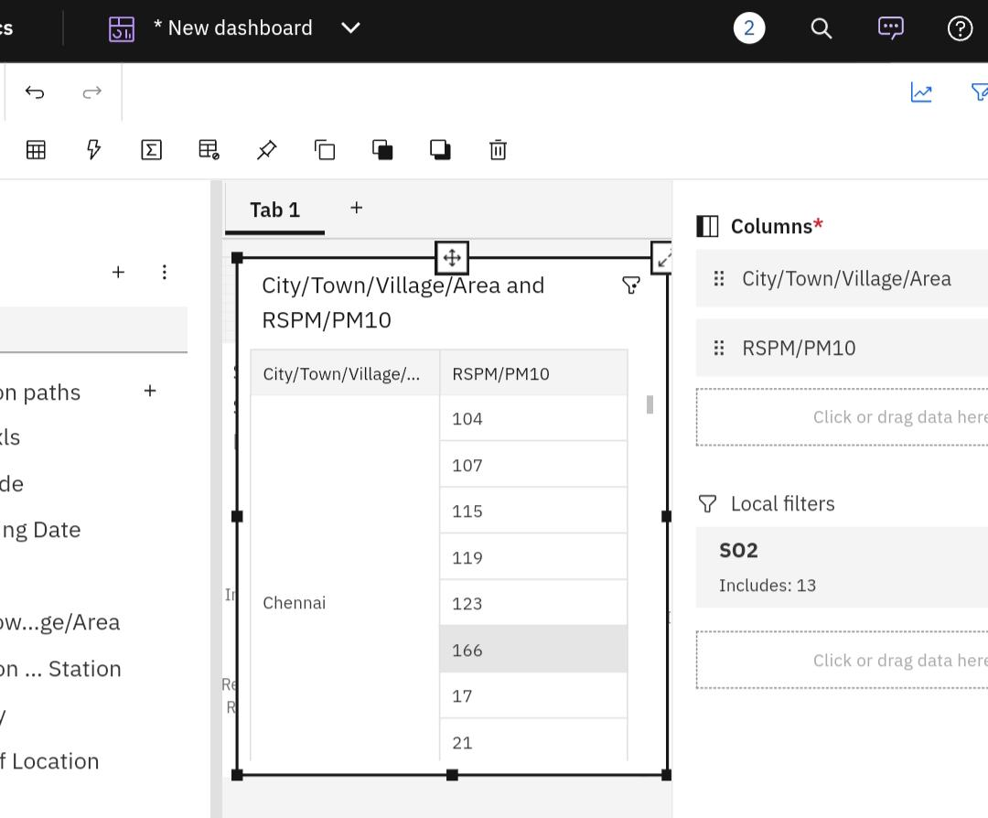

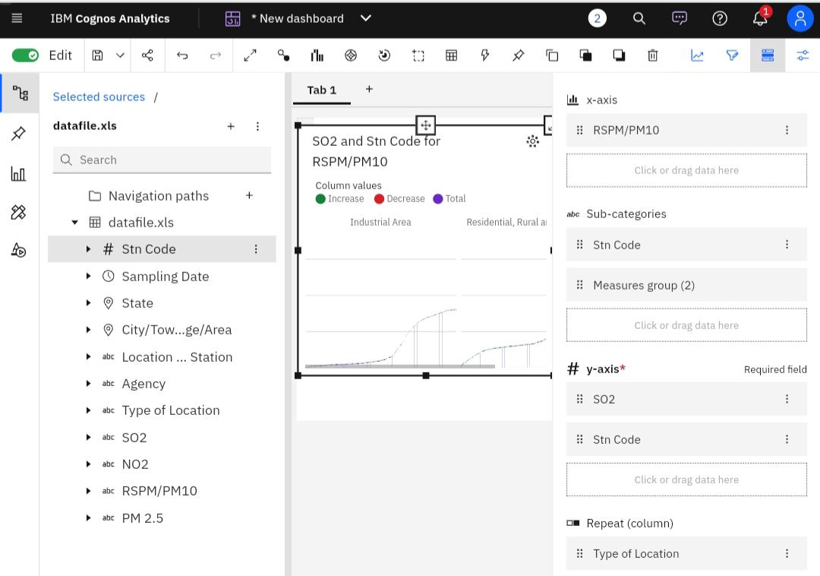

**Conclusion**

The generated graph images through ibm platform made us to understand about the air quality analysis through the tamilnadu state and it greatly helped for our easy prediction about air quality analysis and it’s bad effects towards people in highly polluted area.

Conclusion